PROJECT-53
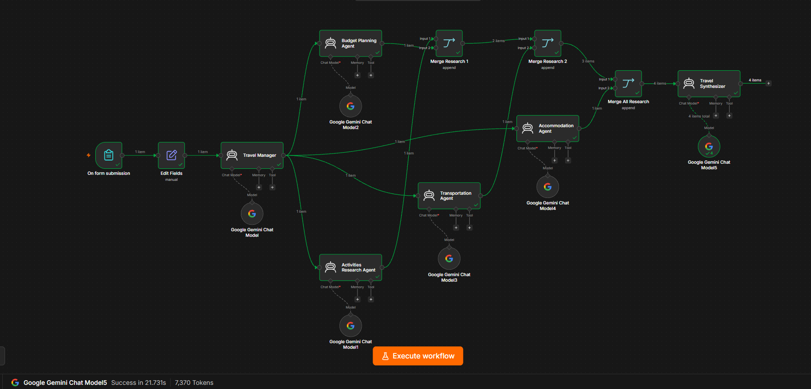
. Project Title
Multi-Agent AI Travel Planner
Difficulty: Hard Level
Platform: n8n
AI Model: Google Gemini Chat Model
Architecture: Multi-Agent + Parallel Research + Merge + Final Synthesis

2. Project Overview
The Multi-Agent AI Travel Planner is an AI-powered workflow that takes a traveler's requirements through an n8n form and generates a complete personalized travel plan.
Instead of asking one AI agent to perform every task, the workflow divides the work among multiple specialized agents:
- Travel Manager
- Activities Research Agent
- Budget Planning Agent
- Transportation Agent
- Accommodation Agent
- Travel Synthesizer
The outputs from the specialist agents are combined using n8n Merge nodes before being passed to the final Travel Synthesizer. n8n's Merge node supports combining multiple data streams, and Append outputs the items from the inputs sequentially.

3. Objective
The main objective is to automatically generate a travel plan based on:
- Destination
- Travel dates
- Number of travelers
- Budget
- Interests
- Travel style
- Accommodation preference
- Transportation preference
The system then produces:
- Day-by-day itinerary
- Activities
- Transportation plan
- Accommodation recommendations
- Food suggestions
- Budget breakdown
- Estimated total spending
- Travel tips
- Assumptions
- Final recommendation

4. Workflow Architecture
Your final workflow follows this architecture:
On Form Submission
↓
Edit Fields
↓
Travel Manager
↓
┌──────┼──────────────┬───────────────┐
↓ ↓ ↓ ↓
Budget Activities Transportation Accommodation
Agent Agent Agent Agent
↓ ↓ ↓ ↓
└───────────────┬──────────────────────┘
↓
Merge Research 1
↓
Merge Research 2
↓
Merge All Research
↓
Travel Synthesizer
↓
Final Travel Plan

5. Input Form
The workflow starts with On Form Submission.
Form fields
Field | Purpose
Traveler Name | Identifies the traveler
Destination | Travel destination
Start Date | Beginning of trip
End Date | End of trip
Travelers | Number of people
Budget | Maximum/target budget
Interests | Activities the traveler likes
Travel Style | Relaxed, balanced, adventure, etc.
Accommodation Preference | Budget, standard, luxury, etc.
Transportation Preference | Public transport, taxi, rental car, etc.
Example
Traveler Name: John
Destination: Washington DC
Start Date: 2026-08-12
End Date: 2026-08-15
Travelers: 2
Budget: $4,000
Interests: Culture, Food, Art, Wildlife, Walking
Travel Style: Balanced
Accommodation: Budget-friendly
Transportation: Public Transport

6. Edit Fields Node
The Edit Fields node prepares the form information for the AI agents.
It ensures that the required fields are available in a consistent structure.
Example:
Destination
Start Date
End Date
Travelers
Budget
Interests
Travel Style
Accommodation Preference
Transportation Preference

7. Travel Manager Agent
The Travel Manager is the orchestration/planning layer.
Its job is to analyze the travel request and determine what each specialist agent should focus on.
Responsibilities
- Understand the travel request
- Identify the trip constraints
- Determine research requirements
- Give context to specialist agents
- Maintain consistency between the different research tasks
Example
For:
Destination: Washington DC
Interests: Culture, Food, Wildlife
Budget: $4,000
the manager can establish research areas such as:
Activities → museums, monuments, wildlife
Budget → accommodation, food, transport, activities
Transportation → Metro, walking, airport transfer
Accommodation → budget-friendly areas and options

8. Activities Research Agent
This agent focuses only on activities.
Responsibilities
- Find suitable attractions
- Consider the traveler's interests
- Organize activities by day
- Consider geographic proximity
- Avoid overloading the itinerary
Example output
Day 1:
National Mall
Smithsonian museums
The Wharf

Day 2:
National Gallery of Art
U Street
Local food experiences

9. Budget Planning Agent
This agent focuses on financial planning.
Responsibilities
- Analyze the travel budget
- Estimate accommodation expenses
- Estimate food expenses
- Estimate transportation expenses
- Estimate activity costs
- Identify potential budget issues
- Recommend allocation of the available budget
Example:
Accommodation: $1,000
Food: $700
Transportation: $300
Activities: $400
Miscellaneous: $200

Estimated total: $2,600
Remaining budget: $1,400
The system should clearly treat these as estimates, not guaranteed live prices.

10. Transportation Agent
This agent handles transportation planning.
Responsibilities
- Analyze transportation preferences
- Recommend suitable transport methods
- Consider distances between activities
- Reduce unnecessary travel
- Estimate transportation costs
Example:
Primary Transport:
Metro + Walking

Airport Transfer:
Metro or airport shuttle

Daily:
Use Metro for longer distances
Walk between nearby attractions

11. Accommodation Agent
This agent handles accommodation planning.
Responsibilities
- Respect accommodation preference
- Consider the traveler's budget
- Recommend suitable areas
- Consider proximity to attractions
- Consider transportation access
Example:
Recommended Area:
Arlington / Silver Spring

Reason:
Lower accommodation cost
Good public transportation access
Reasonable access to Washington DC attractions
Again, the agent should not claim that a hotel is currently available unless a real-time hotel/booking tool is connected.

12. Merge Research 1
The first Merge combines two specialist outputs.
Activities Agent ─────┐
↓
Merge Research 1
↑
Budget Agent ─────────┘
Configuration
Mode: Append
Number of Inputs: 2
Output:
Item 1 → Activities Research
Item 2 → Budget Research
n8n's Append mode keeps the data from all inputs and outputs the items sequentially.

13. Merge Research 2
The second Merge adds transportation research.
Merge Research 1 ───────┐
↓
Merge Research 2
↑
Transportation Agent ───┘
Configuration
Mode: Append
Number of Inputs: 2
Expected output:
Item 1 → Activities
Item 2 → Budget
Item 3 → Transportation

14. Merge All Research
The third Merge adds accommodation research.
Merge Research 2 ──────┐
↓
Merge All Research
↑
Accommodation Agent ───┘
Configuration
Mode: Append
Number of Inputs: 2
Expected output:
Item 1 → Activities
Item 2 → Budget
Item 3 → Transportation
Item 4 → Accommodation
This was an important improvement over the original workflow because the Synthesizer now receives all specialist outputs through its actual execution path.

15. Travel Synthesizer
The Travel Synthesizer is the final AI Agent.
Its job is to combine all four specialist outputs and create one final travel plan.
Input
It receives:
4 specialist research items
using:
{{ JSON.stringify($input.all()) }}
This avoids directly referencing disconnected specialist branches.
n8n expressions are evaluated within the current workflow execution context, so designing the workflow around the actual execution path helps avoid the disconnected-node expression problem you encountered earlier.

16. Travel Synthesizer Responsibilities
The Synthesizer must:
- Read all specialist research.
- Compare recommendations.
- Resolve conflicts.
- Respect the traveler's budget.
- Respect travel dates.
- Prioritize traveler interests.
- Create a realistic itinerary.
- Group geographically close activities.
- Balance activities and rest.
- Produce a final professional report.

17. Final Output Structure
Your final output should contain:
TRIP OVERVIEW

Traveler:
Destination:
Dates:
Number of Travelers:
Budget:

DAY-BY-DAY ITINERARY

Day 1
Morning:
Afternoon:
Evening:
Transportation:
Food:
Estimated Spending:

Day 2
Morning:
Afternoon:
Evening:
Transportation:
Food:
Estimated Spending:

ACCOMMODATION RECOMMENDATION

TRANSPORTATION PLAN

ACTIVITIES SUMMARY

FOOD & DINING

BUDGET BREAKDOWN

ESTIMATED TOTAL COST

ASSUMPTIONS

TRAVEL TIPS

FINAL RECOMMENDATION
Your screenshot shows that your actual output is already following this general structure. ✅

18. AI Models
You used Google Gemini Chat Model for the AI Agents.
Each specialist has its own AI Agent and Gemini model connection:
Travel Manager
↓
Gemini

Activities Agent
↓
Gemini

Budget Agent
↓
Gemini

Transportation Agent
↓
Gemini

Accommodation Agent
↓
Gemini

Travel Synthesizer
↓
Gemini
This allows each agent to have a different role and system instruction.

19. System Message Strategy
Each agent should have a different system message.
For example:
Budget Agent
You are the Budget Planning Agent.

Your job is to analyze the traveler's budget and create a practical financial plan.

Focus on:
- Accommodation
- Food
- Transportation
- Activities
- Miscellaneous expenses

Use estimates where exact prices are unavailable.

Never claim that estimated prices are guaranteed.
Transportation Agent
You are the Transportation Research Agent.

Your job is to create a practical transportation strategy.

Consider:
- Traveler preference
- Distance between activities
- Public transportation
- Walking
- Local transportation
- Airport transfers

Do not invent real-time schedules or prices.
Synthesizer
The Synthesizer has the strongest system instructions because it is the final decision-making layer.

20. Why This Is a Hard-Level Project
This project is harder than your previous single-agent projects because it includes multiple AI components working together.
Beginner
Form → AI Agent → Output
Medium
Form → AI Agent → AI Agent → Output
Your project
┌→ Specialist Agent
├→ Specialist Agent
Form → Manager ────┼→ Specialist Agent
└→ Specialist Agent
↓
Merge
↓
Synthesis
↓
Output
This introduces:
- Multi-agent architecture
- Agent specialization
- Parallel branches
- Data aggregation
- n8n expressions
- Merge nodes
- Prompt engineering
- System messages
- Context management
- Final AI synthesis
That's why I would classify your current implementation as Hard Level.

21. Error You Encountered and How You Fixed It
Initially, your Synthesizer attempted to directly access outputs such as:
{{ $('Transportation Agent').item.json.output }}
This produced an error because the referenced node wasn't on the Synthesizer's execution path.
The solution was:
Specialist Agents
↓
Merge Nodes
↓
Travel Synthesizer
Now the Synthesizer receives the research through its immediate input.
This is a useful n8n concept to understand: node connectivity and execution context matter when using expressions.

22. Testing Checklist
Before considering the workflow complete, test:
Form
- Form submits successfully
- All fields received
Manager
- Travel Manager executes
Specialist Agents
- Activities executes
- Budget executes
- Transportation executes
- Accommodation executes
Merges
- Merge Research 1 → 2 items
- Merge Research 2 → 3 items
- Merge All Research → 4 items
Synthesizer
- Receives merged research
- Gemini connected
- Generates one final output
- Final output contains itinerary
- Budget is included
- Transportation is included
- Accommodation is included
- Activities are included

23. Limitations
Your current project is an AI planning system, not a live booking system.
Without external tools/APIs, it should not claim:
- Live hotel availability
- Live flight availability
- Exact current hotel prices
- Exact transportation schedules
- Current weather
- Completed bookings
If you later connect external tools, the agents can retrieve live information. n8n's AI Agent architecture supports using external tools and APIs for actions and information retrieval.

24. Future Improvements
To make this project even more advanced, you could add:
Level 1 upgrade
Weather Agent
Weather API
↓
Weather Agent
↓
Travel Synthesizer
Level 2 upgrade
Live hotel search
Hotel API
↓
Accommodation Agent
Level 3 upgrade
Flight search
Flight API
↓
Transportation Agent
Level 4 upgrade
Quality Control Agent
Travel Synthesizer
↓
Quality Checker
↓
Final Approved Plan
Level 5 upgrade
Add a feedback loop:
Final Plan
↓
Quality Check
↓
Problems?
↙ ↘
Yes No
↓ ↓
Revision Final Output
↓
Synthesizer
That would make the architecture significantly more advanced.

25. Project Summary
Project: Multi-Agent AI Travel Planner
Difficulty: Hard
Platform: n8n
LLM: Google Gemini
Input: Travel form
Agents: 6
Merge Nodes: 3
Output: Personalized travel plan
Complete flow
┌──────────────────────┐
│ On Form Submission │
└──────────┬───────────┘
↓
┌──────────────────────┐
│ Edit Fields │
└──────────┬───────────┘
↓
┌──────────────────────┐
│ Travel Manager │
└──────────┬───────────┘
│
┌─────┼─────┬─────────┐
↓ ↓ ↓ ↓
Activities Budget Transportation Accommodation
│ │ │ │
└─────┴─────┴─────────┘
↓
Merge Research 1
↓
Merge Research 2
↓
Merge All Research
↓
Travel Synthesizer
↓
┌──────────────────┐
│ Final Travel │
│ Plan │
└──────────────────┘
Final assessment: Your completed workflow is a genuine hard-level n8n multi-agent project and is suitable as a strong portfolio project.

